**1.0 Introduction** **2**

**2.0 Concept and Goals** **2**

2.1 RoboTour Specification 2

2.2 User Interface 2

2.3 Marketing: Market, User & Solution 2

2.3.1 Beachhead Target Market: UK Museums 3

2.3.2 Target User 1 - Visitors with Language Barriers 3

2.3.3 Target User 2 - Visitors who require directional assistance 4

2.4 Physical Mockup 5

3.0 Time Planning 5

3.1 Technical Milestones for Client Demo 5

3.1.1 Client Demo 1 - 07/02/2018 5

3.1.2 Client Demo 2 - 28/02/2018 5

3.1.3 Client Demo 3 - 14/03/2018 6

3.1.4 Final Client Demo - 05/04/2018 6

3.2 Resource Deployment (200 hours/member) 6

3.3 Team Strengths 7

3.0 Time Planning 7

3.4 How will you set up a space on level 3 to demonstrate 7

3.5 Delegation and Volunteering 7

**4.0 Dependencies and Risks** **7**

4.1 Gantt Chart 7

4.2 Prototype Constraints 7

4.3 Human Risks 8

4.3.1 Distribution of work 8

4.3.2 Team member conflict 8

4.3.3. Not meeting deadlines? 8

4.4 Technical Risks 8

4.4.1 Robotic Mapping 8

4.4.2 Tripping Hazard 9

4.4.3 Essential Equipment Out of Budget (not provided as standard) 9

**5.0 Organisational Structure** **9**

5.1 Task Allocation 9

5.2 Meetings 9

5.3 Communications 10

5.4 Code/File-Sharing 10

5.5 Progress Monitoring/Tracking 10

5.6 Development Approach 10

# 

# 

# 1.0 Introduction

This document describes the project plan for team RoboTour. Our product can solve 2 main problems. Roboutour provides Museum visitors who with directional assistance by taking them to the piece of art they were looking for**.** This is particularly useful forvisitors who does not speak the local language, RoboTour can display the users the UI in their language.

# 2.0 Concept and Goals

RoboTour is an multi-purpose assistive robot tailored to museum visitors. RoboTour’s mission is to provide a truly immersive cultural experience for underserved visitors by increasing inclusivity through robot guiding assistance and elimination of language barriers.

## 2.1 RoboTour Specification

RoboTour provides 4 key features:

1. Multi-language support in Human-Robot Interaction via speech and app
2. Speaks description of art pieces in multiple languages
3. Guides visitor to a specific art piece and points it
4. Provides recommendations and optimal route planning

## 2.2 User Interface

Visitors with interact with the robot via an Android app via touchscreen and voice. The advantage of using an Android app is that most people would have a phone and existing speech recognition API from Google allows speech interaction between visitors and robots.

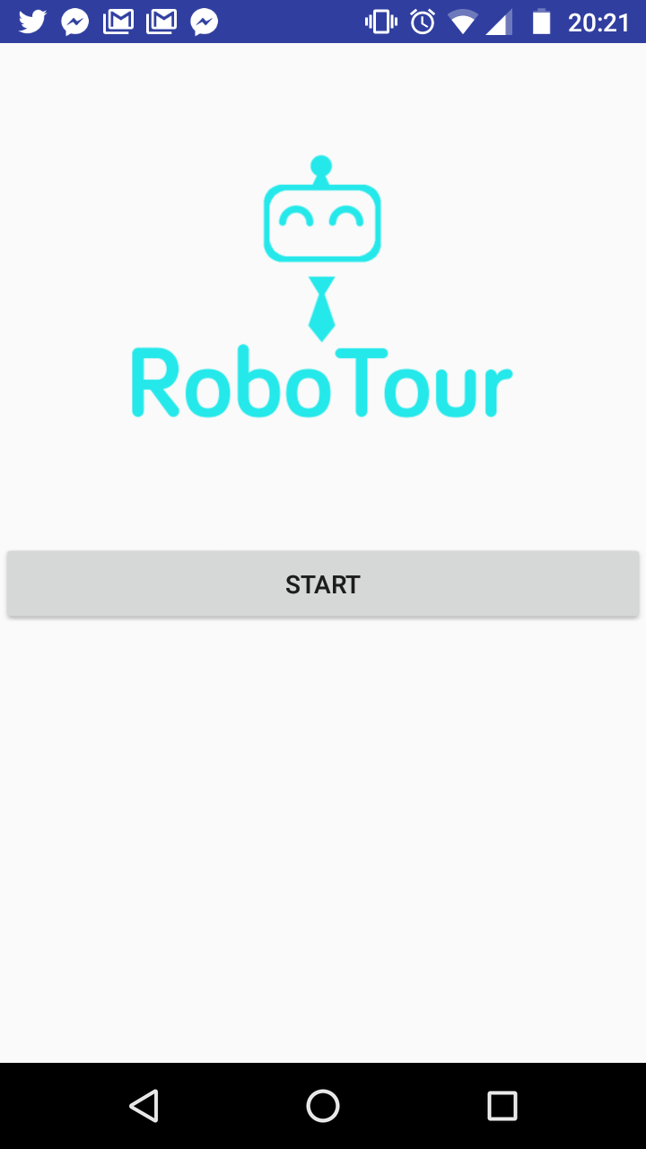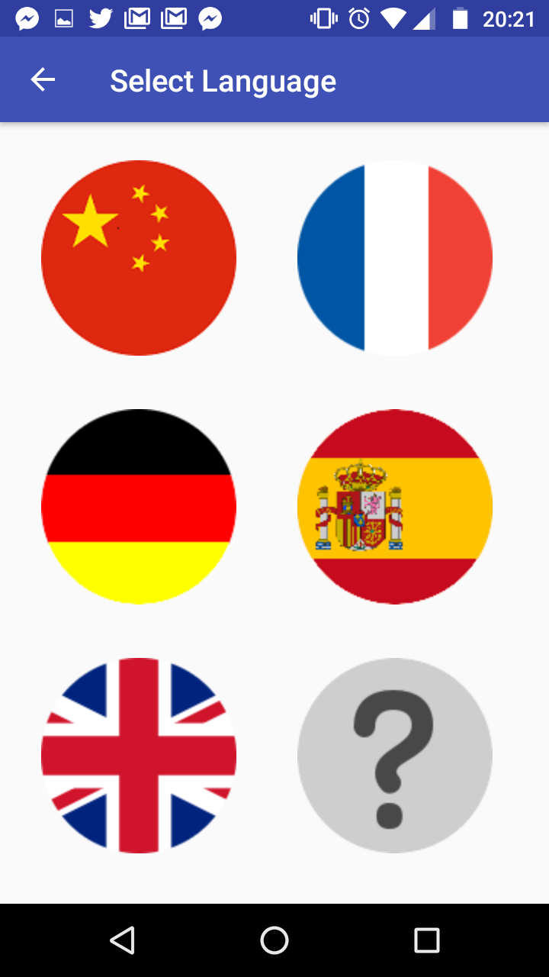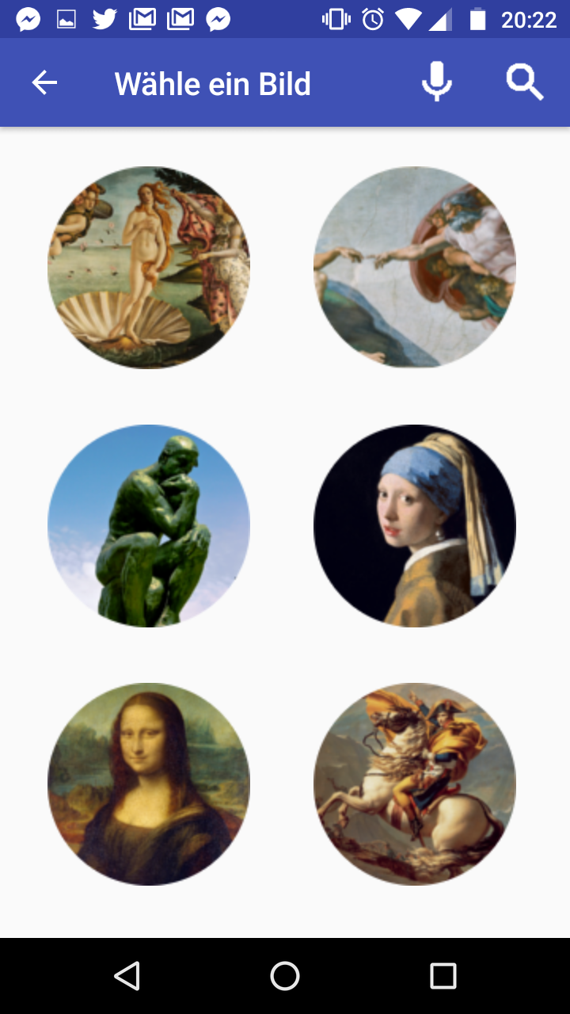

## 2.3 Marketing: Market, User & Solution

Beachhead strategy is adopted so RoboTour can concentrate on winning the market of one country before looking into other countries. UK museum is RoboTour’s beachhead market because of 2 key reasons: easier to carry out primary research, and personal experience with the user problems outlined next. RoboTour is an multi-purpose assistive robot tailored to museum visitors. RoboTour’s mission is to provide a truly immersive cultural experience for underserved visitors by increasing inclusivity through robot guiding assistance and elimination of language barriers.

### 2.3.1 Beachhead Target Market: UK Museums

RoboTour’s target markets are UK museums which are looking to improve visitor experience and increase revenue from underserved customer segments by providing a truly immersive cultural experience using assistive robotics technologies.

### 2.3.2 Target User 1 - Visitors with Language Barriers

**Problem:** UK museums have limited languages offering and are mostly dominated by English so visitors with no or limited fluency in the languages offered by museums are underserved, and thus cannot enjoy cultural immersion extensively.

**Evidence:** According to Fig 1, around 50% of annual museum visitors are from overseas. Based on primary observations, approximately 40% of them come from countries where English is not the main language.

**Solution:** RoboTour’s feature 1 and 2 from section 2.1.

**Value Proposition - Revenue Increase:**

1. Better cultural immersion for overseas visitor
2. Attracts new overseas visitor
3. Increased customer retention rate
4. Improved visitor experience and increased likelihood to spend

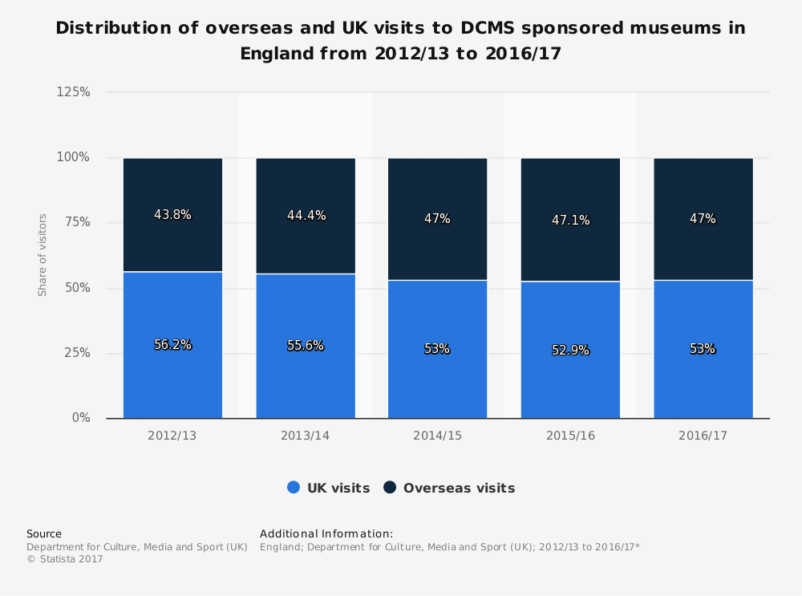

Fig 1: Distribution of overseas and UK visits to Museums in England.

### 2.3.3 Target User 2 - Visitors who require directional assistance

**Problem:** With the constant changing dynamics of art pieces in museums and limited staff training, staff member in large museums often do not know where a specific art piece is. Therefore, visitors struggle to visit all art pieces of interest effectively under time constraints, thus leading to lower visitor satisfaction and missing out on some art pieces.

**Evidence:** Based on primary research, majority of visitors do not know where an art piece of their interest is located in the museum. Under these circumstances, visitors would consult leaflet maps or staff members.

**Solution:** RoboTour’s feature 3 and 4 from section 2.1. According to Fig 2, speech recognition is regularly used for 3 main common tasks: finding information on a product, asking questions and asking for directions. This justifies why RoboTour is a speech enabled assistive robot.

**Value Proposition - Cost Reduction:**

1. Lower staffing cost in terms of headcount and training.
2. Lower time costs for visitors due to improved museum visitors traffic flow (optimal route planning)

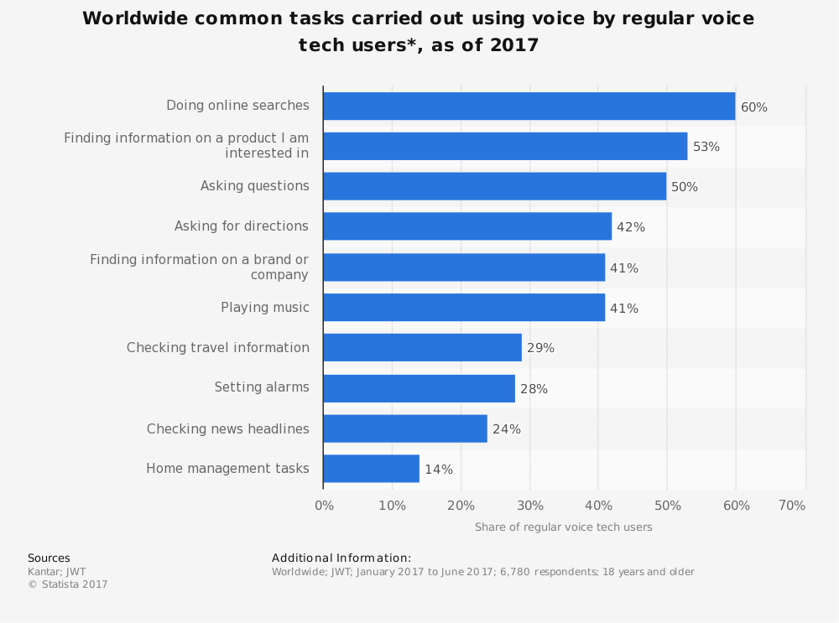

Fig 2: Most common tasks carried out using voice recognition (e.g. Google Assistant and Siri)

## 

## 

## 2.4 Physical Mockup

This is a preview of the robot. Further modification will be made after each client feedback.

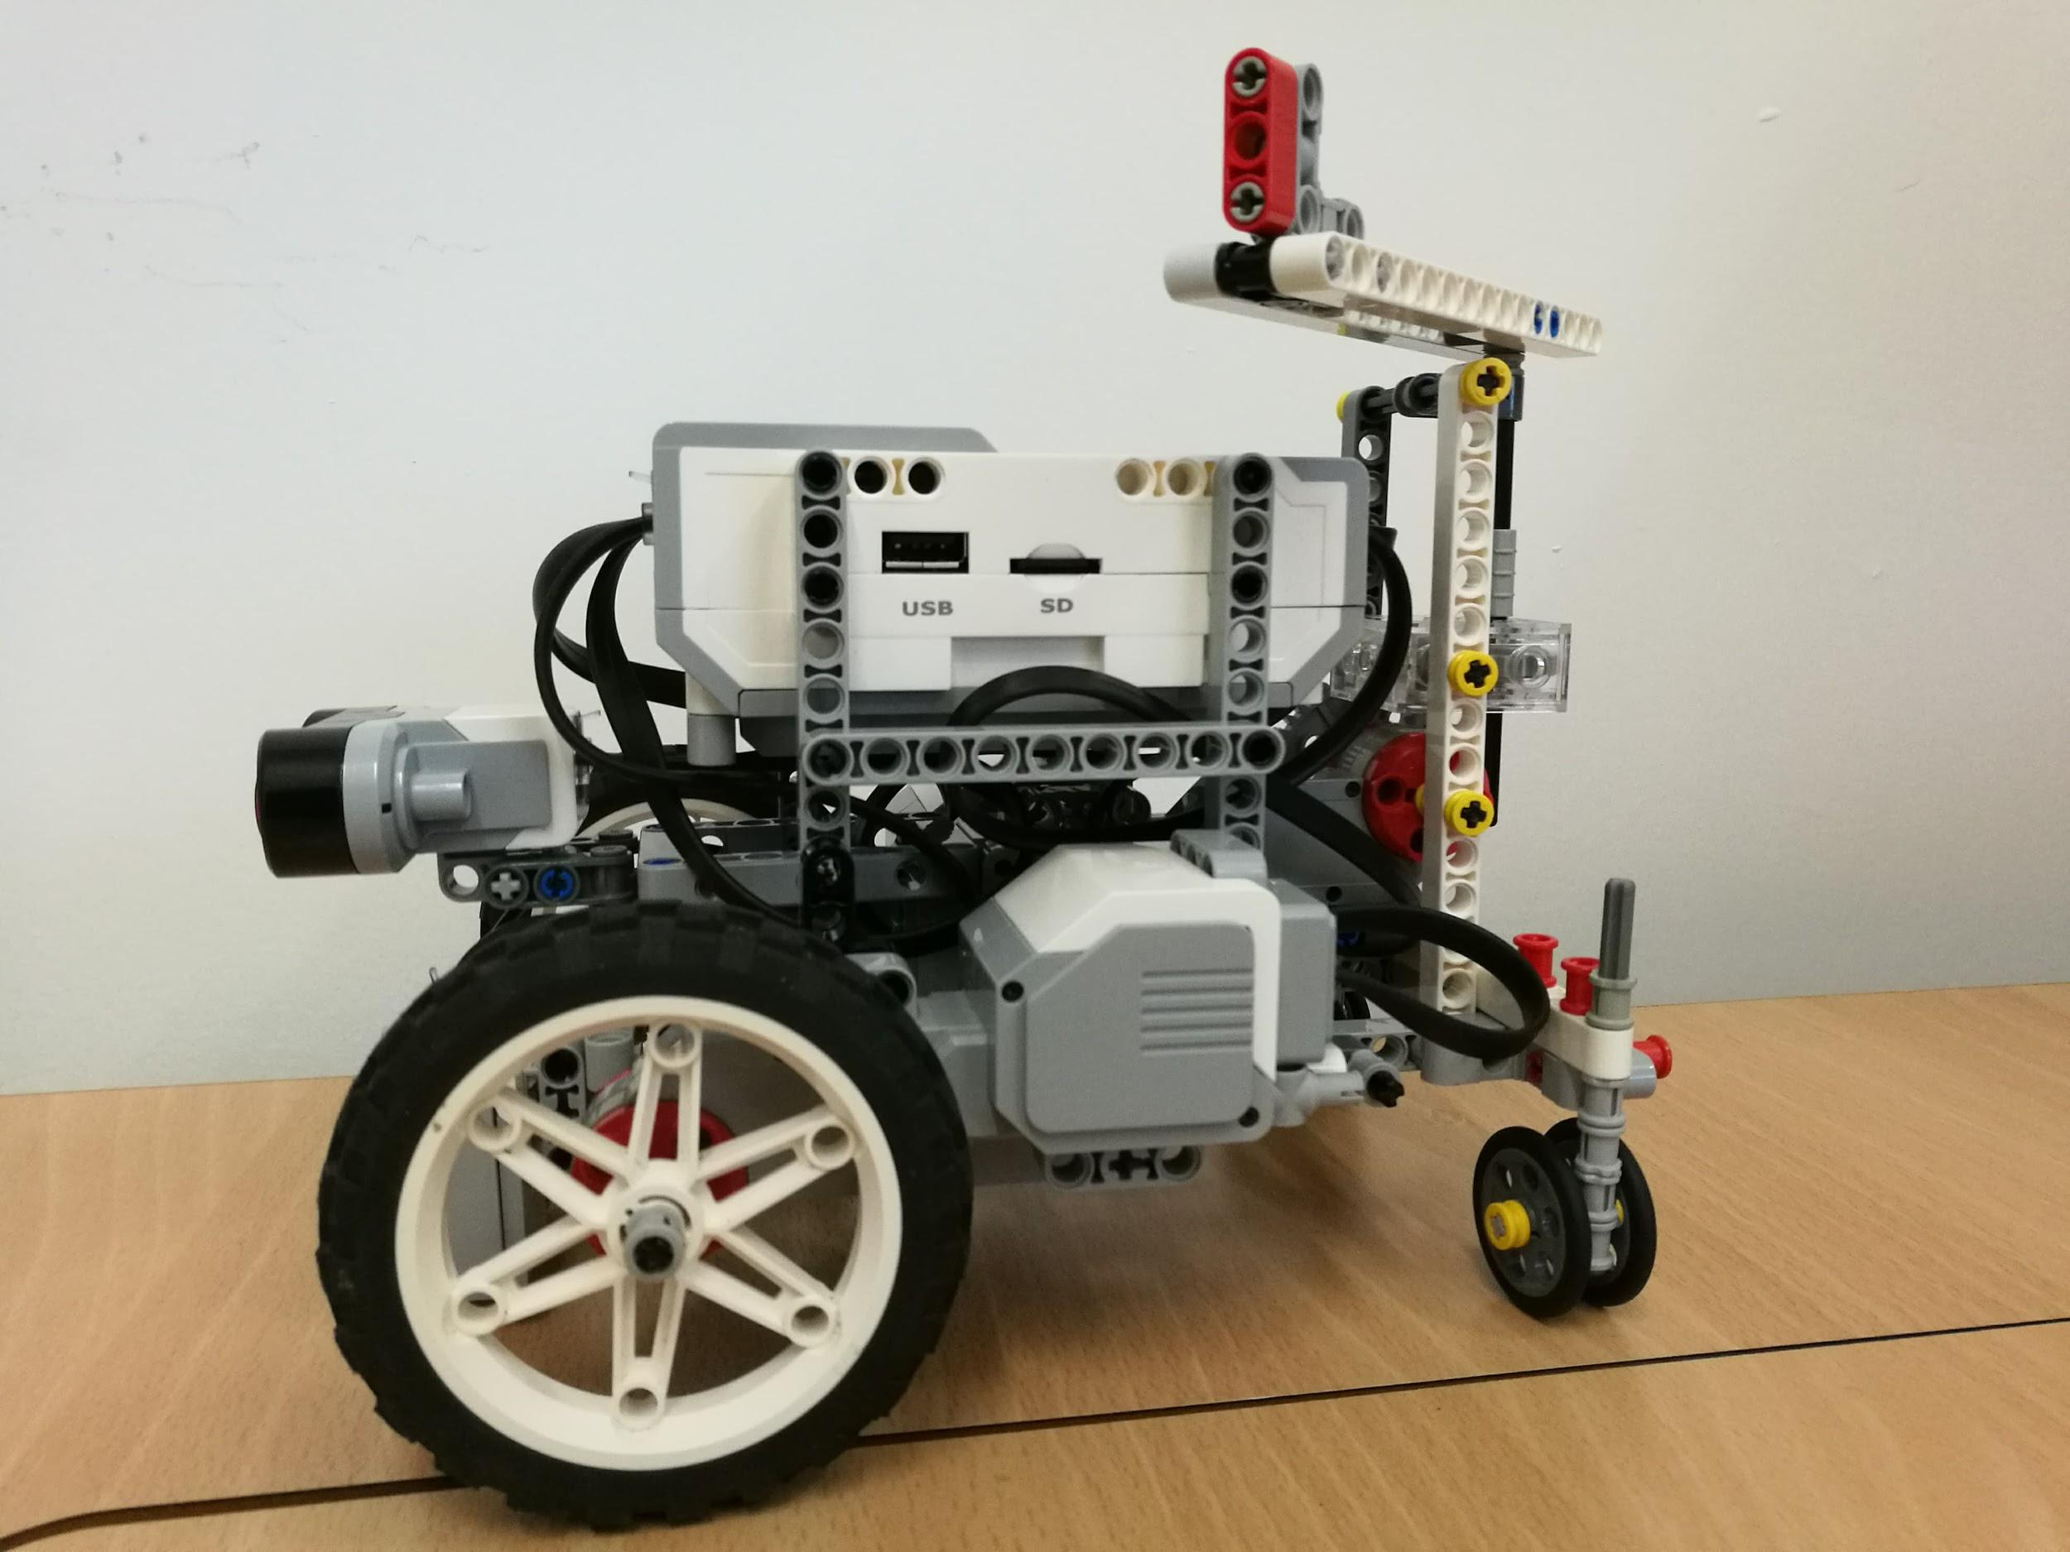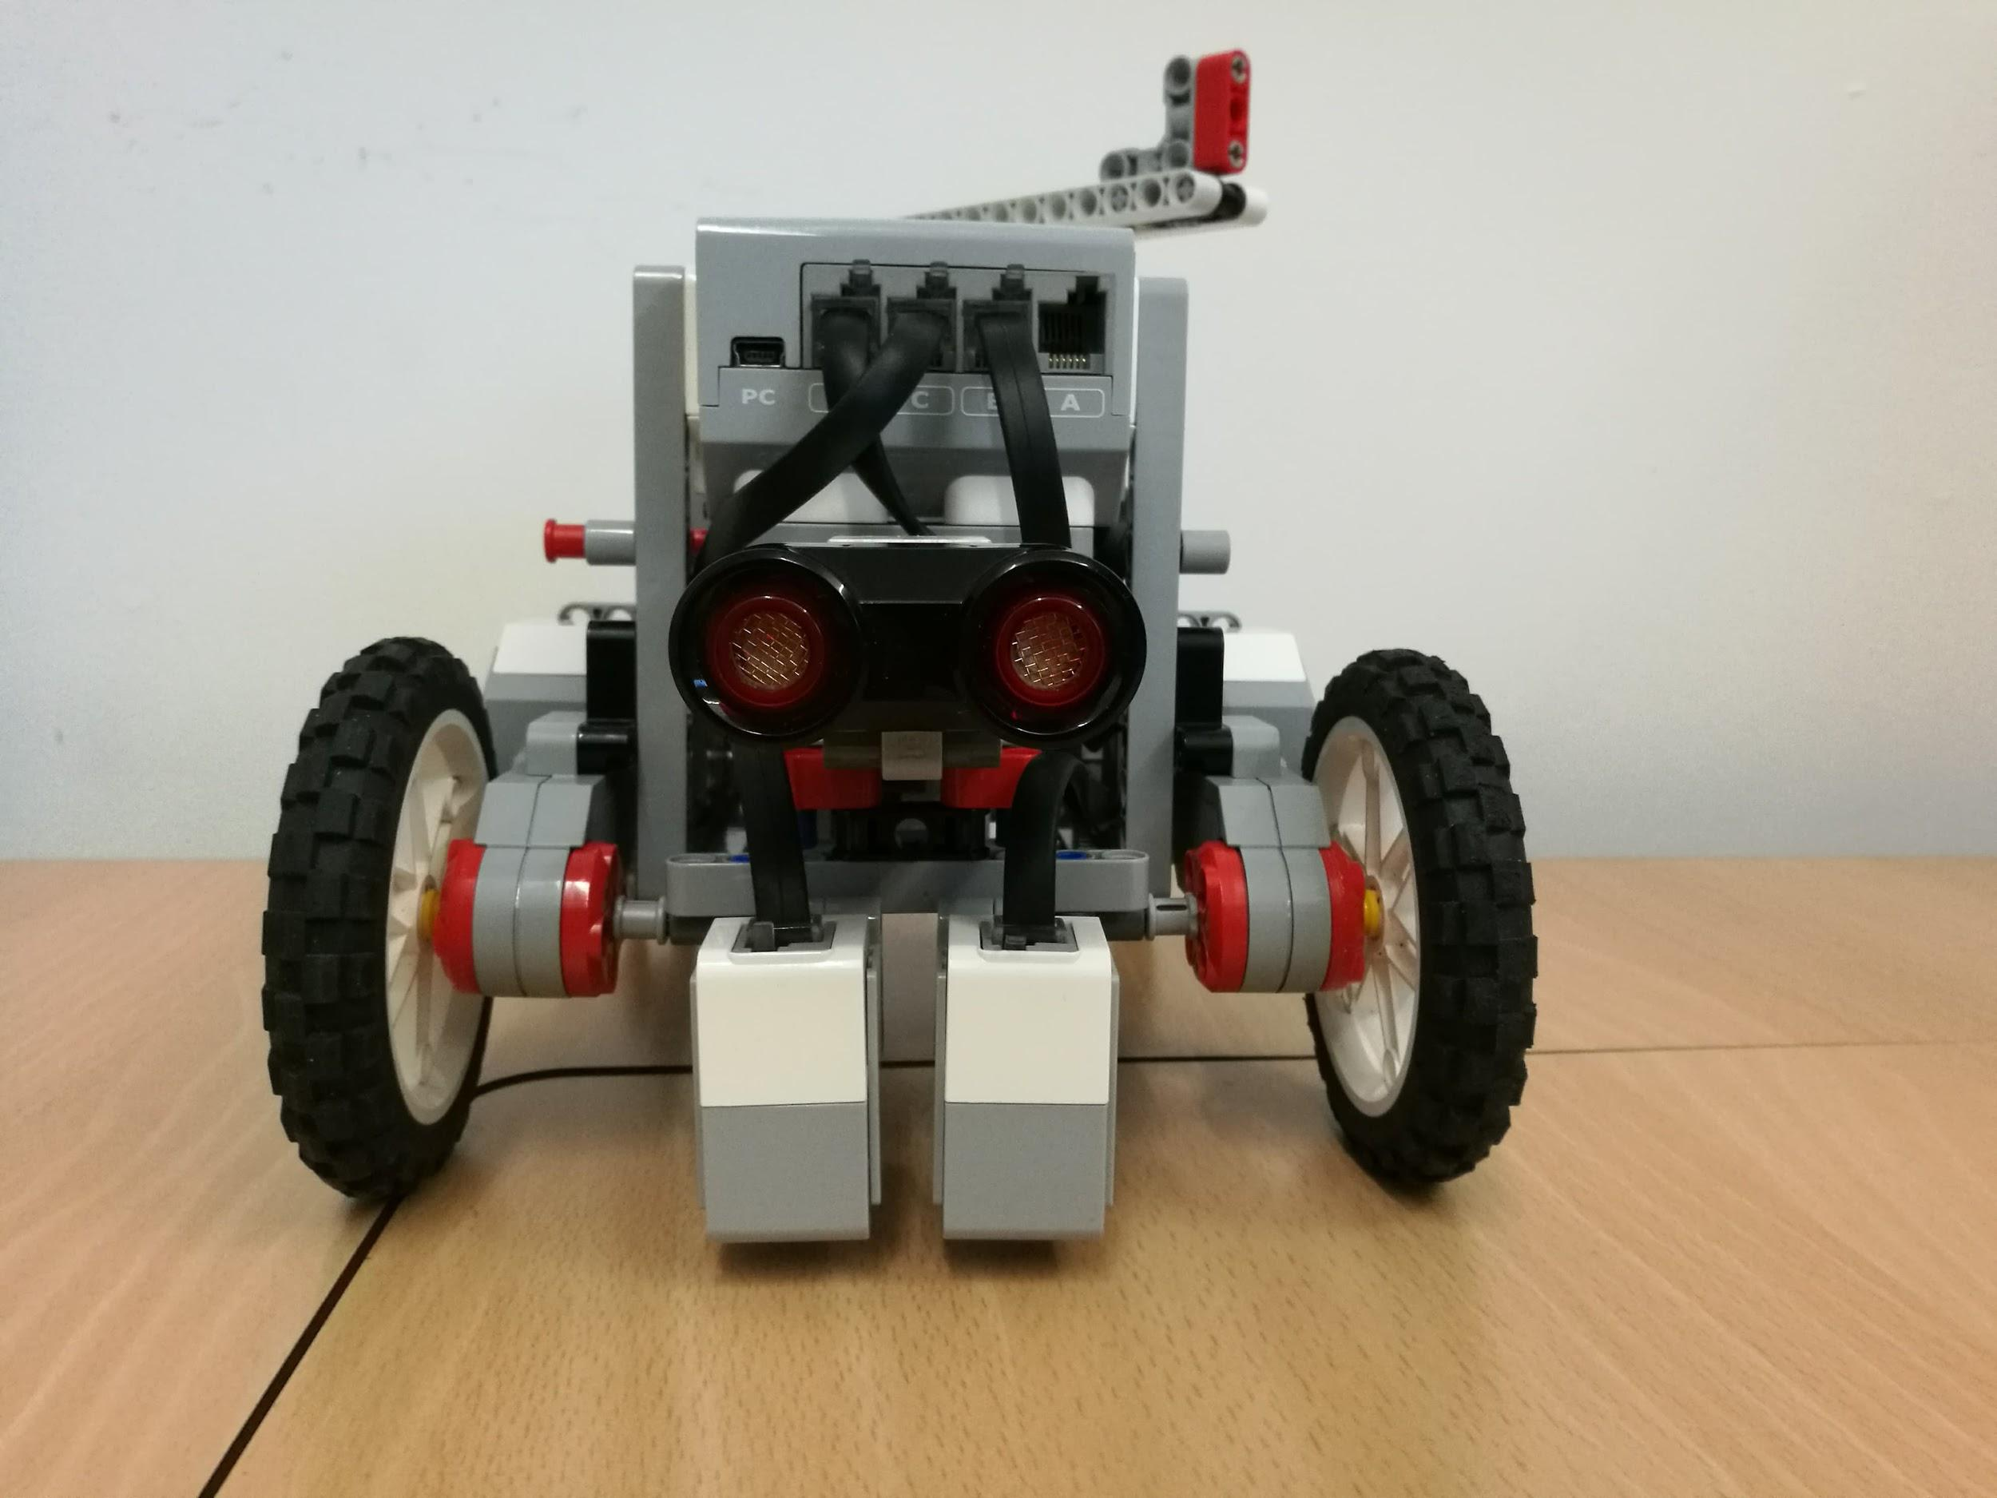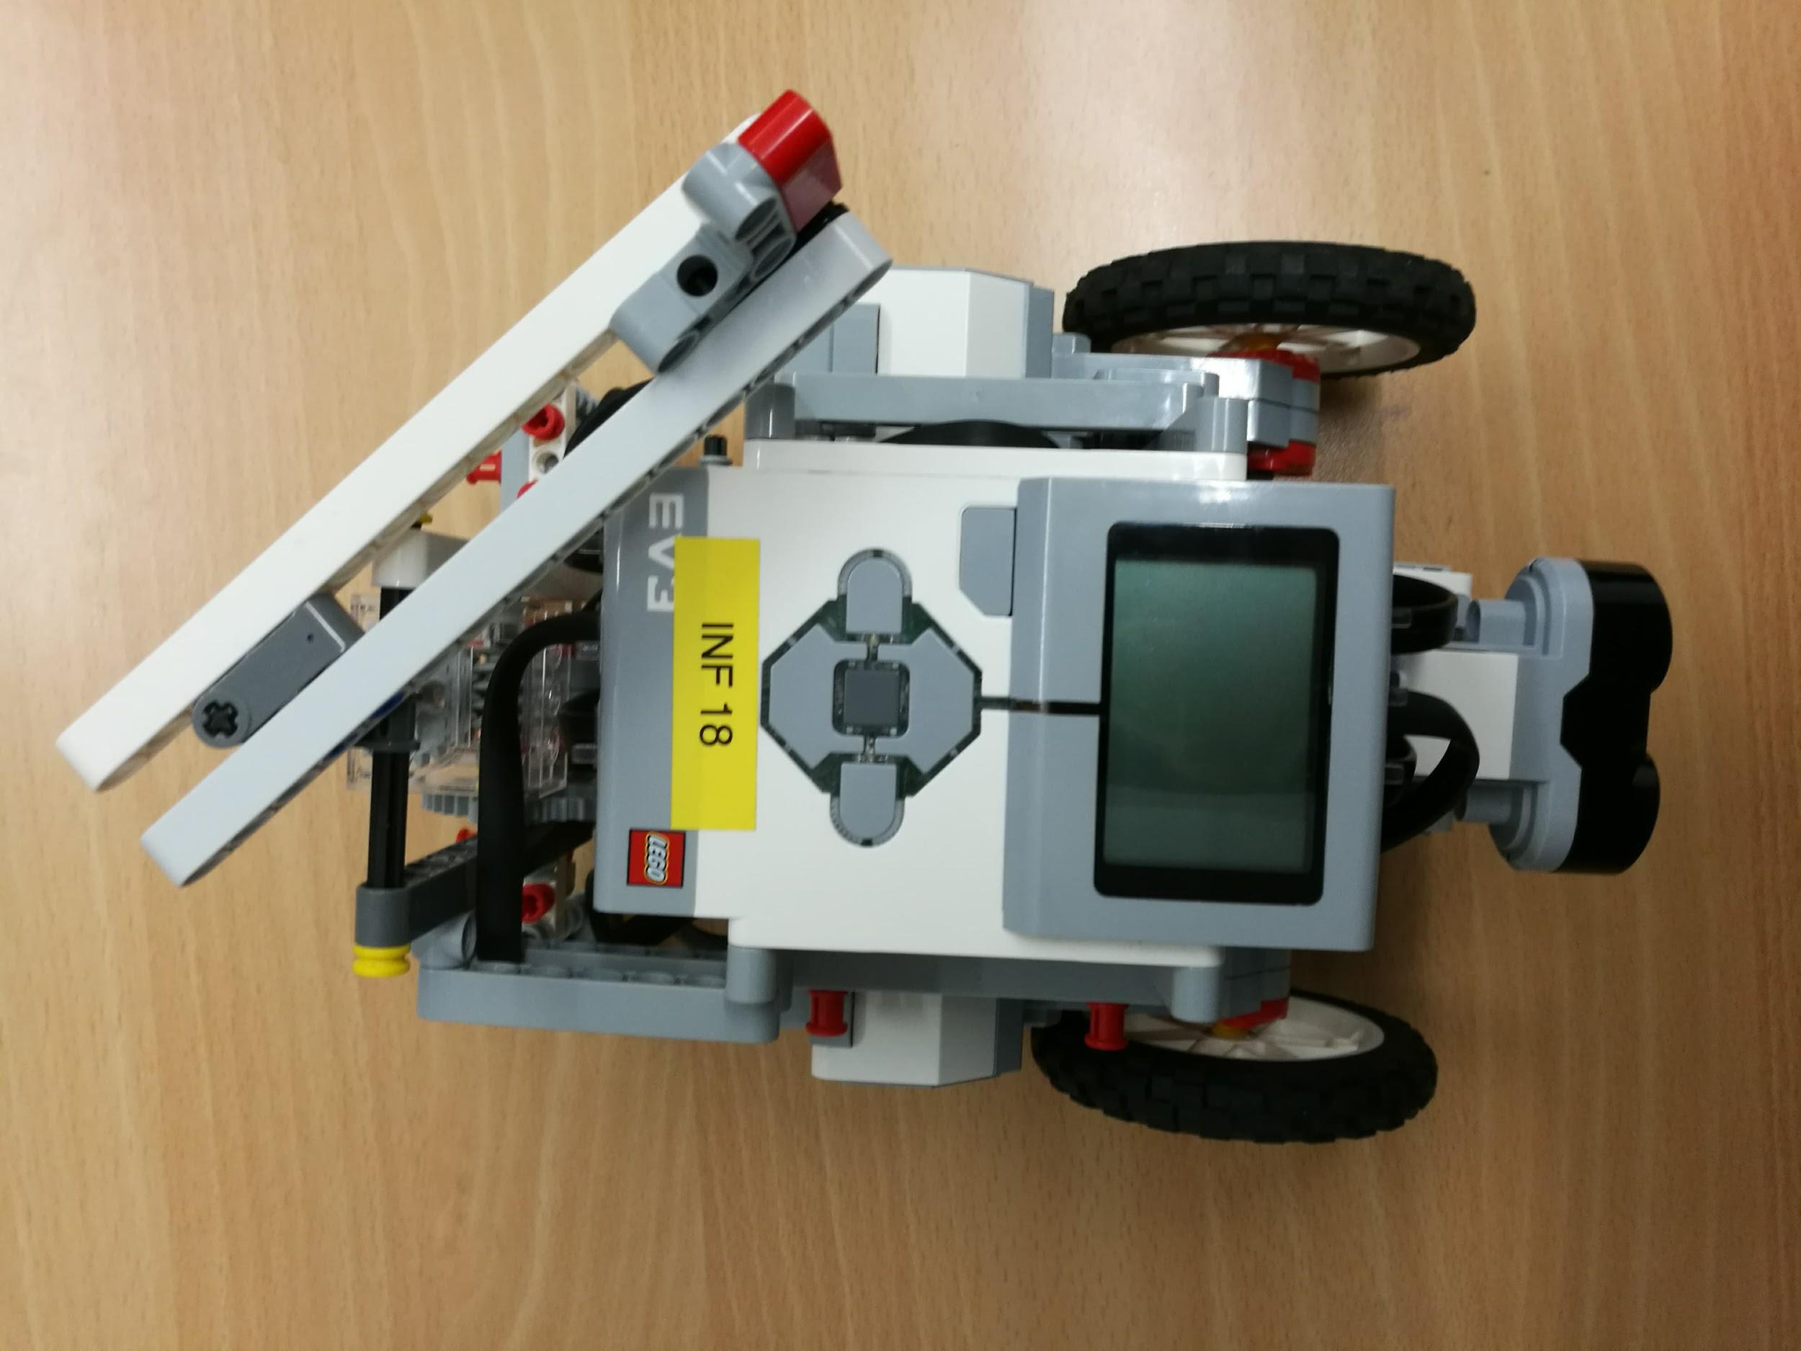

## 3.0 Time Planning

## 3.1 Technical Milestones for Client Demo

### 3.1.1 Client Demo 1 - 07/02/2018

|  |  |
| --- | --- |
| **Technical Achievement** | **Evidence** |
| Basic robot built | Can show client robot with bare features: Infrared sensors, 2 colour sensors, 3 motors, 4 wheels (2 motorised and 2 for stability) |
| Robot can carry out preset commands | Show client robot can be instructed to move to a predefined locations by selecting a image from the app. |
| User Interface | Android app with basic user interface driven by images. User can interact via touchscreen only. Multiple languages are supported. |
| Static object avoidance | When the robot detects an object in front of it, it stops within x centimetres so as to avoid |

### 3.1.2 Client Demo 2 - 28/02/2018

|  |  |
| --- | --- |
| **Technical Achievement** | **Evidence** |
| Following line paths | The robot can move and turn static branching line paths. |
| Basic Speech Commands | User can interact with the robot through app via English speech. User can send basic commands to robot. For example, user can ask the robot to “Take me to X”. |
| Dynamic collision avoidance | Showing the client if a human is in front of robots path, the robot will stop and move backward if human comes closer than x centimeters. |

### 3.1.3 Client Demo 3 - 14/03/2018

|  |  |
| --- | --- |
| **Technical Achievement** | **Evidence** |
| Speed limit | Allows user to specify the speed to for the tour or guidance. |
| Dynamic collision avoidance and navigation | Moving around objects blocking preferred path by calculating a secondary route by using a second line |
| Improved User Interface | Allows user to ask the robot for recommendations via text or speech. |

### 3.1.4 Final Client Demo - 05/04/2018

|  |  |
| --- | --- |
| **Technical Achievement** | **Evidence** |
| Stability | We will demonstrate to the client how the robot has achieved our set goals reliably from previous demos and per the specification. |
| Polish | We will improve on any features from previous demos that needed polish or enhancement. We will show our improved UI to the client, which will be designed to be more user friendly compared to previous versions. |

## 3.2 Resource Deployment (200 hours/member)

We aim to use the 200 hours per member as efficiently as possible. Below is detailed anticipated usage of the time per group member to achieve our goals.

This is a guide to how time will be distributed amongst different tasks for each member. Although this may change e.g. If a member is on the hardware side, they may spend more time on the robot and less time coding and vise versa.

|  |  |
| --- | --- |
| **Task** | **Approx time in hours** |
| Guest lectures | 6 |
| Demos | 4 |
| Group meetings (incl expected extra meetings) | 25 |
| Planning | 40 |
| Debugging & Testing | 30 |
| Code Reviewing | 10 |
| Building robot | 10 |
| Coding | 75 |
|  | **Total: 200** |

## 3.3 Team Strengths

|  |  |
| --- | --- |
| **Name** | **Technical Strengths** |
| Michal Dauenhauer | Electronic circuits design and assembly, embedded programming, |
| Mahbub Iftekhar | Project management, Java, Kotlin, Android Development, C++, Databases, Networking, Hardware debugging |
| Deividas Lavrik | Java, Python, C++, Networking, Algorithms and Data Structures, LEGO |
| David Speers | Java, Kotlin (+Anko), Android Development, Python (+ Numpy, Pandas, matplotlib |
| Alice Wu | Java, Android Development, Databases, Networking |
| Finn Zhan Chen | Speech processing, Marketing, Market Research, Pitch making, Android development, Python, Java |
| Mariyana Cholakova | Java, Python, Android Development, Research |

## 3.0 Time Planning

## 3.4 How will you set up a space on level 3 to demonstrate

We plan to set up mock corridors using the existing layout at the back of the large lab as a demonstration with minor modification to adapt to having mock artwork to

## 3.5 Delegation and Volunteering

We have been allocating jobs on a skills basis. It is allowed for members to volunteer to do tasks they feel comfortable doing. If volunteers are not found the group leader will allocate roles based on

# 4.0 Dependencies and Risks

## 4.1 Gantt Chart

## 

## 4.2 Prototype Constraints

* WIth the current model the robot can only move on the lines
* It requires a static environment - thus expecting the museum not to change
* LImited processing power means that it is limited on the processes it can do, and hence what the prototype can achieve.

## 4.3 Human Risks

### 4.3.1 Distribution of work

Major tasks will be allocated and revised regularly during our weekly meeting or in a group discussion. Whenever a team member attempts to complete a task he/she is responsible to inform the team upon his decision and if he requires assistance, as well as in case he would not be able to complete it on time. The team manager also assigns tasks and ensures meeting of deadlines, and asks at key moments how everything is going and checks if everything is on track. We reflect every meeting in Meeting Notes which are shared in Google Drive. This ensures every team member can easily refer to all decisions taken during the meeting and can quickly stay updated with the changes in case he had missed the sessions.

### 4.3.2 Team member conflict

In cases where the issue is of higher priority and/or voting is not decisive, we may require the advice of the mentors. Possible conflicts between team members are acknowledged, and like in any team are likely to occur. We are planning to approach this type of problems by group voting. The major vote would determine the final decision. If we have for example three routes and are split and cannot make a unanimous decision, we operate a system of removing the least popular item then discussing further and then voting on the 2 most popular routes to hopefully achieve a unanimous vote - and importantly so we make the right decision for the group.

### 4.3.3. Not meeting deadlines?

We have a contingency plan for deadlines as we set internal deadlines which are closer than the deadline itself. An example of this is for this document, we had an internal deadline for all members to have their first drafts by Tuesday at 7 pm before the deadline, in order to allow contingency time in case a member is ill, as a group we can cover their share of the task as we still have time until the deadline. This approach also aligns with our agile development strategy and allows time to receive a feedback from the client,make appropriate adjustments and have time for group proofreading.

4.3.4. Communication and information consistency

To avoid the risk of redundant and inefficient communication, discussions take place in group chats and channels with all team members. More detailed overview of our means of communication is provided in Section 5.3.

## 4.4 Technical Risks

### 4.4.1 Robotic Mapping

The mapping of the area will prove to be one of the most difficult tasks to achieve.

Due to the complexity of the problem we are planning to research this topic in greater depth. In addition, we will consider scheduling extra time on working, reassuring we would be able to deal with unexpected problems if such occur.

### 4.4.2 Tripping Hazard

It is possible that the users can trip over the robot. This

### 4.4.3 Essential Equipment Out of Budget (not provided as standard)

Cheaper alternative? Be less ambitious with the robot feature?

# 5.0 Organisational Structure

We have split into

**Team leader & admin**: Mahbub

**Marketing**: Finn (Lead)

**App**: David (Lead), Mahbub, Alice, Finn

**Software** **Robot**: Michal (Lead), Finn, Michal, Devidas, Alice, Mariyana, Mahbub

**Hardware** **Robot**: Devidas (Lead), Mahbub, Michal

## 5.1 Task Allocation

|  |  |
| --- | --- |
| Task | Members |
| Driving Robot | Mahbub, Deividas, Michal |
| Environment Sensing | Deividas, Michal |
| App to EV3 Communication | Mahbub, Finn |
| App UI | David, Alice |
| Line Following | Michal, Deividas |
| Basic Speech Commands | Finn, Mahbub |
| Dynamic Collision Avoidance | David, Alice |
| Dynamic Navigation | Finn, Mahbub |
| Improve UI | David, Alice |
| Speed Limit | Michal, Deividas |
| Polish | Deividas, Michal, Mahbub |
| Stability | Finn, David, Alice |

## 5.2 Meetings

We organised meetings at least once per week to discuss the current progress and the next target. Meetings are organised by the mentor and the manager. We also communicate primarily through Slack to ask technical questions and get status updates. Meeting notes were taken in every meeting and is properly formatted for easy retrieval in Google Drive.

## 5.3 Communications

We are using Slack for task discussion, Messenger for other discussions and using emails to contact mentor and client.

Trello is the main tools for our team to manage the task. Tasks in Trello’s board are displayed as cards, and each card is assigned to groups such as “to discuss” and “To do”. In this case, each team member can find the task quickly.

## 5.4 Code/File-Sharing

GitHub is the main tools for our team to shared codes and version control.

Files are saved and shared in private Google Drive. Such files as Project plan, user guide etc, this is to allow multiple members of the group to work on the same document at the same time, maximising efficiency.

## 5.5 Progress Monitoring/Tracking

There are meeting notes for every meetings, where recorded the process and the next target. Meeting notes are shared in Google drive so each teammate can read easily.

## 5.6 Development Approach

We are using Agile software development methodology. In addition to online communications like Slack and Messenger, our team organized weekly face-to-face meetings to discuss the progress of the project. Meanwhile, we are using GitHub for code sharing and Google drive for other documents sharing. Codes are included comment lines to provide an easy reading environment for everyone. At the same time, we get in touch with the client once we submit the client demo. We will then improve the product according to the client’s feedback, and try to respond to the change in a short time.